درخت تجزیه برای برنامه‌ی نوشته شده در زبان SQL:

SELECT name, country FROM Authors as au WHERE au.genre = 'fiction';

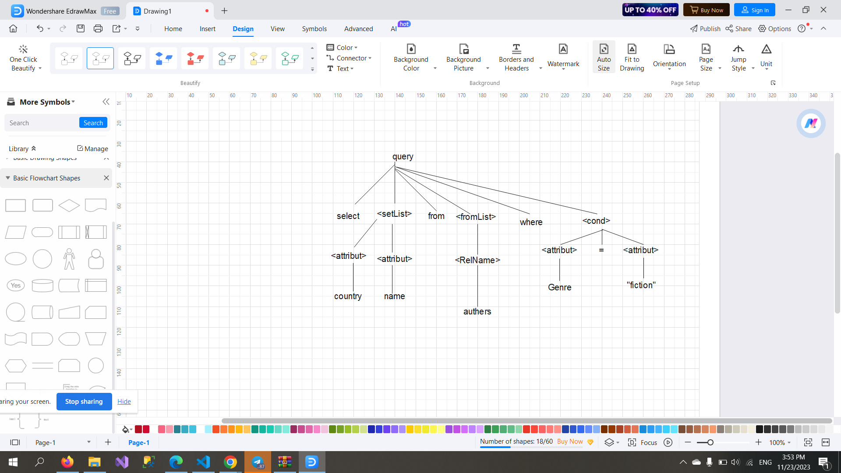

SELECT title, price FROM Books WHERE rating = 5;

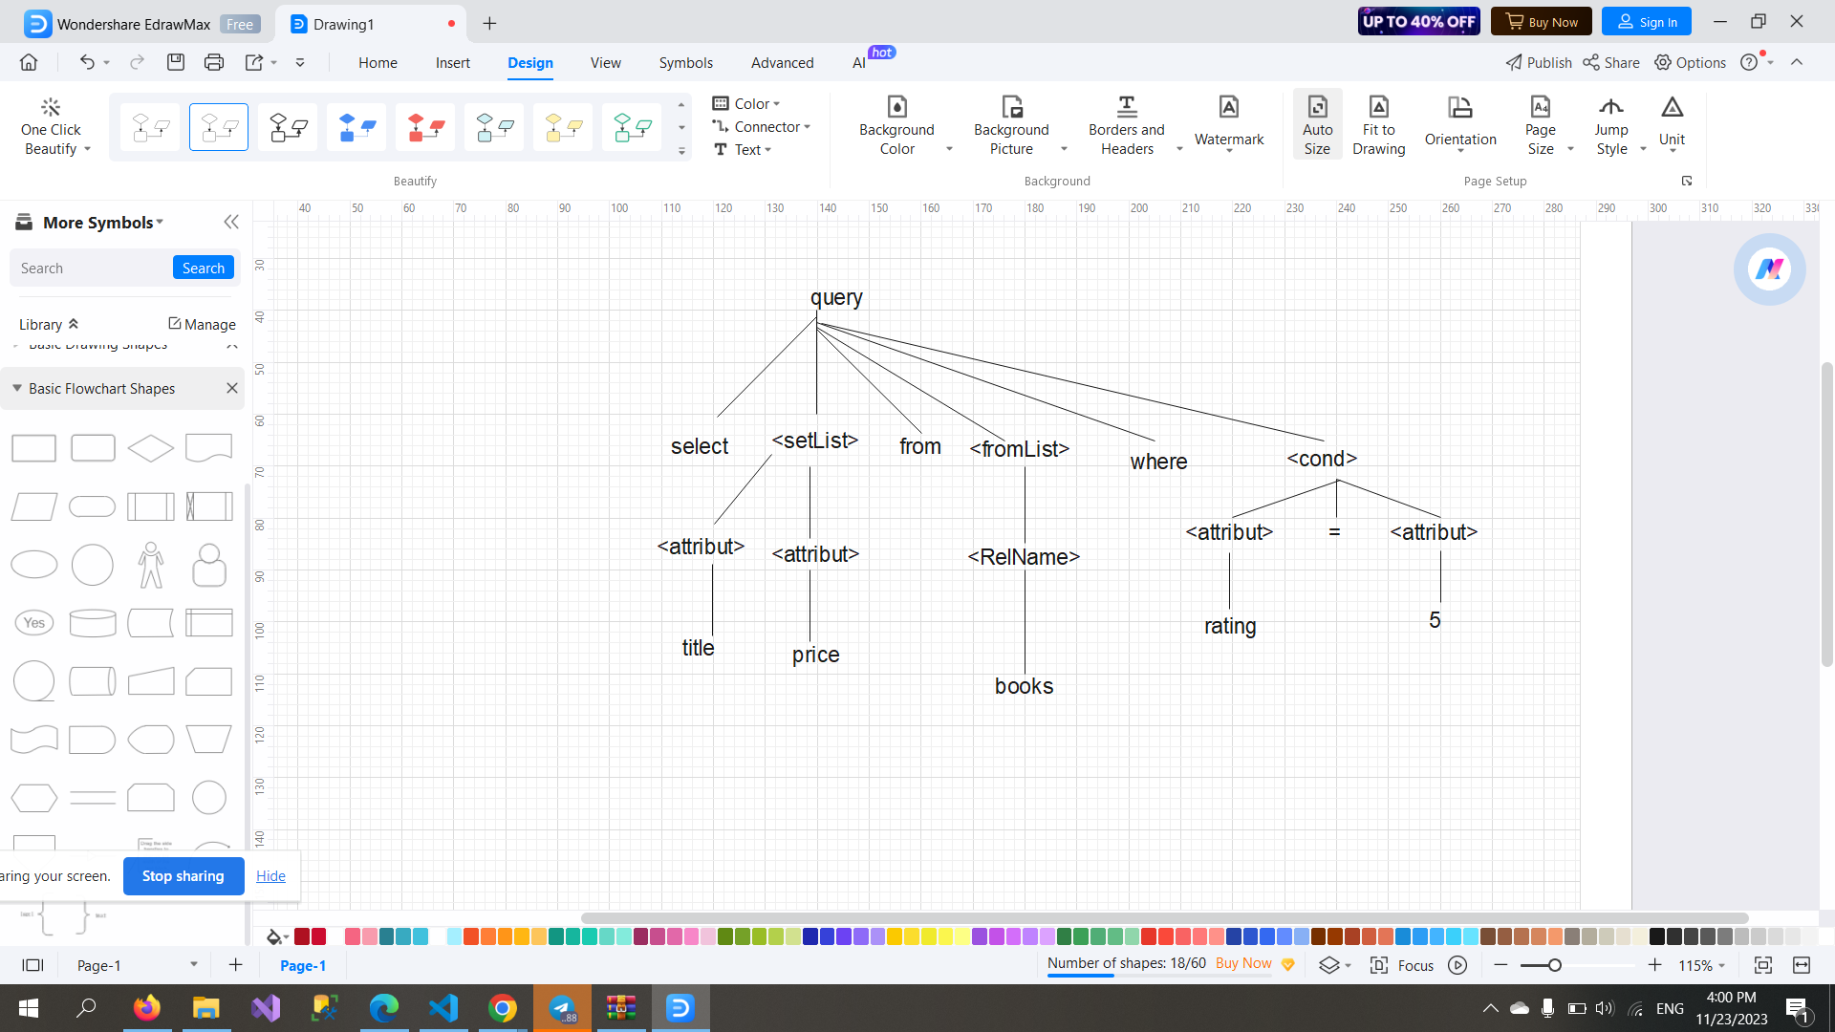

SELECT Authors.name, Books.title FROM Authors INNER JOIN Books ON Authors.id = Books.author_id;

